**EXPERTISE WITHIN WORKING MEMORY AND FLUID INTELLIGENCE**

A Master’s Thesis

Presented to

The Graduate College of

Missouri State University

TEMPLATE

In Partial Fulfillment

Of the Requirements for the Degree

Master of Science, Experimental Psychology

By

Addie Wikowsky

August, 2019

Copyright 2019 by Jane Ann Doe

**EXPERTISE WITHIN WORKING MEMORY AND FLUID INTELLIGENCE**

Psychology Department

Missouri State University, August 2019

Master of Science

Addie Wikowsky

**ABSTRACT**

The formatting of this abstract should be one paragraph without indenting and single spaced. The length of the abstract is limited to this space so that everything fits on this one page. There must be at least two single-spaced blank lines between the abstract and the line with keywords.

Last line of abstract

**KEYWORDS**: list at least five to ten keywords or phrases here: use lowercase and separate with commas; note that if two lines are used, the second line is not indented

**EXPERTISE WITHIN WORKING MEMORY AND FLUID INTELLIGENCE**

By

Addie Wikowsky

A Master’s Thesis

Submitted to the Graduate College

Of Missouri State University

In Partial Fulfillment of the Requirements

For the Degree of Master of Science, Experimental Psychology

August, 2019

Approved:

|  |
| --- |
| Erin M. Buchanan, Ph.D., Thesis Committee Chair |
| Melissa D. Fallone, Ph.D., Committee Member |
| Dana C. Paliliunas, Ph.D., Committee Member |
| Julie Masterson, Ph.D., Dean of the Graduate College |

In the interest of academic freedom and the principle of free speech, approval of this thesis indicates the format is acceptable and meets the academic criteria for the discipline as determined by the faculty that constitute the thesis committee. The content and views expressed in this thesis are those of the student-scholar and are not endorsed by Missouri State University, its Graduate College, or its employees.

**ACKNOWLEDGEMENTS**

If desired, a page can be inserted for the purpose of acknowledging the assistance and support of others. Single spacing is acceptable if necessary to keep this all on one page.

I would like to thank the following people for their support during the course of my graduate studies.

A dedication can be included as well. It should be separated from the rest of the acknowledgement. The following is an example.

I dedicate this thesis to (insert person to be dedicated here).

**TABLE OF CONTENTS**

|  |  |
| --- | --- |
| Literature Review | Page 1 |
| Working Memory | Page 1 |
| Fluid Intelligence | Page 1 |
| Measuring Working Memory and Fluid Intelligence | Page 2 |
| Expertise | Page 6 |
| Interplay Between these Systems | Page 8 |
|  |  |
| Methods | Page 10 |
| Participants | Page 10 |
| Materials | Page 10 |
| Procedure | Page 16 |
|  |  |
| Results | Page 18 |
| Descriptive Statistics | Page 18 |
| Hypothesis Tests | Page 18 |
|  |  |
| Discussion | Page 20 |
|  |  |
| Conclusion | Page 22 |
|  |  |
| References | Page 23 |

**LIST OF FIGURES**

|  |  |
| --- | --- |
| Figure 1. Letters of AOSPAN presented to participant | Page 11 |
|  |  |
| Figure 2. Math operation of AOSPAN presented to participant | Page 12 |
|  |  |
| Figure 3. Example of APM | Page 13 |
|  |  |
| Figure 4. Prompt used for typing test | Page 14 |
|  |  |
| Figure 5. Example of typing test results | Page 14 |
|  |  |
| Figure 6. Example of a foreign language placement exam question | Page 15 |
|  |  |
| Figure 7. Point breakdown of placement exam for each language used | Page 16 |

**LITERATURE REVIEW**

**Working Memory**

Working memory has been a critical component to human cognition studies in the literature. Baddeley (1986) describes working memory (WM) as the temporary storage of stimuli being encoded. Working memory plays its biggest role as part of short-term memory (STM). STM, defined by Baddeley (1986), is when you can hold a short amount of information for a limited time. STM works in an interacting system that serves higher level mental processes. These higher level mental processes include reasoning, problem-solving, and learning.

Baddeley and Hitch (1994) first proposed a working memory model in 1974. Their model included the concept of a phonological loop, visuospatial sketchpad, and central executive. The phonological loop (previously the articulatory loop) has two parts: phonological storage and subvocal rehearsal. Phonological storage is when a person holds a sound memory trace until this trace is then rehearsed by the subvocal rehearsal of the model by repeating the trace internally. Baddeley and Hitch’s memory model additionally includes a visuospatial sketchpad, which is primarily responsible for visual and spatial encoding. Visual encoding would be when a person receives an incoming image or stimuli and their brain is recognizing it so they can respond appropriately. Baddeley and Hitch (1994) explain that the visuospatial sketchpad is a type of work space for incoming information. The final piece of their model is the central executive. The central executive is responsible for controlling when the phonological loop and visuospatial sketchpad are used, and how they interact with one another (Baddeley, 2002).

**Fluid Intelligence**

There are copious amounts of brain mechanisms that work into how much you can hold in your working memory. One factor is intelligence, specifically fluid intelligence (*gF*). Horn (1968) describes intelligence as behavior that can be observed and measured. Horn is describing that, for researchers in the behavioral sciences, intelligence needs to be measured in some aspect for it to be considered observable. Jaeggi et al. (2008) classify *gF* as a human ability that allows participants to adapt their thinking to the problem at hand regardless of acquired knowledge. In addition, Gray, Chabris, and Braver (2003) highlight that *gF* is related to attentional control, or a person’s ability to disregard any interference that could affect performance. Gray et al. also say that attentional control is necessary for the abstract thinking needed for *gF.* Horn (1968) reports that Cattell presented the idea of *gF* in 1941 at an APA convention. Since then it has grown popular in the behavioral sciences as a way to measure intelligence that is always expanding.

**Measuring Working Memory and Fluid Intelligence**

Working memory has been tested in the field of psychology since Miller introduced the “magic number” in 1956. The magic number is the concept of how many single items we can hold in our memory, Miller (1965) suggested that we can hold seven items, plus or minus two (5 or 9). This is why phone numbers can be easier to remember, since they fall in that threshold. Working memory has recently been measured with two types of tasks outlined by Yuan et al. (2006), the two types of measurement are: simple memory span and dual-tasks. Simple memory span tasks are when a participant is presented with a stimuli (words, numbers, or positions) and then asked to recall them in either the same or reversed order they were presented. Simple span tasks are generally used to measure short term memory (Mathy, Chekaf, & Cowan, 2018). Dual-trials tasks are when both processing and storage are both being encoded at the same time. Conway et al. (2005) identified that the majority working memory measurements are considered dual-task because of their complexity. More modern working memory measurements are considered complex span tasks, rather than dual-task (Schmiedek, Hildebrandt, Lovden, Wilhelm, & Lindenberger, 2009). This distinction occurs because of the two components required for the task: the processing component and the storage component.

One of the most used complex span tasks to measure working memory is the Operation Span (OSPAN) created by Turner and Engle (1989). In the OSPAN, the participant is given a math problem which they have to identify the solution as correct or incorrect (processing component) with a word or letter being presented after they answer. The participant is then supposed to recall (storage component) those words after a few trials. For example, a participant might answer “is 2X3 + 4 = 5?” with FALSE, then be shown a letter or word after they say FALSE. In the original OSPAN task, a researcher sat with the participant and controlled the speed of the study (i.e., hit the spacebar to move between trials) and recorded the answers for each participant.

The original OSPAN and the automated OSPAN (Unsworth, Heitz, Schrock, & Engle, 2005) are still the same task, but the automated OSPAN is available completely online, without required researcher interaction to move the study forward. This online presentation allows for less confounding variables between the researcher and the participant. The automated OSPAN also has a practice period where the participant is presented with a math problems. After the math practice, they are given a sample trial of math problem where they are told to remember a letter after answering whether the math problem was true or false. After both practice portions are completed the participant then begins the real study. The participants must maintain 85% accuracy for the math operations in order for their data to be considered useful (Unsworth et al., 2005). After the task is completed, the researcher is given the participants scores. The first is a raw score of the correctly recalled letters or words for each set. The researcher is also given a report on the participants math errors to account for accuracy.

Daneman and Carpenter’s (1980) Reading Span Task (RSPAN) is another example of a complex working memory measurement. The authors originally had two ways of testing reading span. In the first part of the RSPAN, participants read sentences out loud to the experimenter. After the participant finished a few sentences, they had to recall the last word in each sentence in order. For the second part, Daneman and Carpenter (1980) had the participant read sentences that were from general knowledge, politics, and other subjects; while still trying to remember the last word. After reading the sentence, the participant had to identify if the statement was true or false. The experimenters were interested in if the participant had recalled the words in order or not for the reading span; however, the true/false verification increased the difficulty of the task, much like the math problems in the OSPAN task. The participants are scored on the number of correct words they recalled in the correct order. For example, the participant is supposed to recall the words: tent, shoe, and bottle. If the participant recalled shoe and bottle, they would receive 2/3. It is important to note for this task that the order is crucial for scoring. For instance, if the participant recalled the same words as above in this order: shoe, tent, bottle, they would still only get a 2/3.

The N-Back task was created in the late 1950’s (Kirchner, 1958). The idea behind this task was to measure short-term memory retention. It consists of different visual stages presented to the participant (Gajewski et al., 2018). After a stimuli is presented, the participant is asked if it matches a stimuli that was presented *n* trails before it. For example, if the stimuli was presented with letters, and this pattern was shown: A, B, D, A. The participant would have to identify if the ‘A’ was presented three trials back. This would be considered a 3-back task because of the number of stimuli in-between the two matching pieces. The stimuli would keep being produced, and the participant would need to keep identifying if the same stimuli was presented before. This process can be repeated with different difficulties, starting with 1-back, the researcher would just increase the number of stimuli between the two stimuli you would want the participant to match. The *n-*back is scored by the reaction times and percentage correct correlated to those in the same age group as the participant. This task challenges the participant because it requires encoding and updating of incoming stimuli while irrelevant stimuli are being introduced (Gajewski et al., 2018).

The Raven Progressive Matrices (RPM) is a measure of *gF*. Raven (1936) initially wanted to develop a test that would allow the researchers to interpret it without any social barriers, as compared to the criticisms of other standardized intelligence tests. In 1988, it was updated and became the Raven’s Advanced Progressive Matrices (APM) (Bors & Stokes, 1998). The participant is presented with several images that represent a complex pattern, and they must pick one of six or eight options that would complete the sequence. The images in the matrix may be rotated, flipped, or change in size. The APM consists of two sets. Set one has 12 items and is generally used as practice for the participant. Set two has 36 items that is more difficult than set one. The participant is scored by how many of their answers were correct. These raw scores are then compared to percentiles based on the participants age. Researchers can also choose to use a time restriction, five minutes for Set one or forty minutes for Set two (Bors, & Stokes, 1998). The time restricts could be used as an assessment of intellectual efficiency, without the time restrictions it can be used to evaluate clear thinking.

Conway et al. (2002) presented a latent variable analysis between WM, *gF*, STM, and processing speed. In their study, they had participants complete multiple simple and complex tasks including the OSPAN, RSPAN, and APM. They found that WM and *gF* were strongly correlated, and that WM and STM were strongly correlated, but *gF* was not linked to STM. The authors suggest that since WM is correlated with STM and *gF* is not, that WM and *gF* are different constructs that need different ways of being tested.

**Expertise**

The last construct that may affect your working memory or fluid intelligence is expertise. Chi, Glaser, and Rees (1982) describe expertise as having an abundance of knowledge and having skill to apply that knowledge. The authors argue that having this knowledge and skill plays a large part in intelligence as a whole. Because participants are able to recall their skill better and faster, they are perceived as more intelligent. This effect has been demonstrated primarily with the skillsets of chess (Chase & Simon, 1973) and physics (Chi, Feltovich & Glaser, 1981).

In Chase and Simon’s (1973) study on chess and memory, they had three classes of participants who played chess. From highest to lowest skillset they were: master, Class A player, and beginner. The way the authors decided to study working memory was to isolate “chunks” that would then be encoded by the participant. These chunks were created by having a chess position set up having one of 28 variations. Chunks refer to Miller (1956) and his “magical number” 7. During the memory task the players were asked to recall different chess positions from memory (Chase & Simon, 1973). The experimental design included two chess boards that were placed in front of the participant. These boards were recreated two ways. The first position presented to the participants, were played games that were arranged in the middle of a match and the second was from randomly placing the pieces on the board. The participant was told to examine the preset board for five seconds and recall the as much as they could remember on the full set board in front of them. The participant was able to repeat memorizing and recalling the board layout until they recalled the original set perfectly. It took those in the master class less trials than the Class A players and beginners to recreate the middle of the match positions. Those in the “master” class could encode the preset chess boards and recreate their model in less trials than the other two groups of participants, because they had more expertise playing chess. This finding suggests that the expertise influenced the results based off the position being a playable game or not.

Chi et al. (1981) looked at the same idea of expertise, but with those in the field of physics. For their categories of participants, they used PhD students in the physics department (experts) and undergraduates who had only completed one semester of a physics course (novices). They were given 24 problems to group together by the how the solution to the problem was to be found. All participants were interviewed after they separated the problems to their respective categories to see how they reasoned why that problem fits with the category they chose. They determined that the experts sorted by the laws of physics, and the novices sorted by surface structures. These surface structures refer to objects, terms, or configurations of the problem presented.

In the second part of the study, the experts and novices were presented a new set of 20 physic problems. This part of the study also included an intermediate participant who was a fourth-year physics major. These problems were created to include both physic laws and surface features combined to see how the participants would categorize them. The results were replicated from the previous study by the expert and the novice participants. Yet, the intermediate participant reasoned both by using the laws of physics and surface structures, showing that they had applied the laws, but not yet left the surface structure. These studies by Chase and Simon and Chi et al., demonstrate that expertise is perceptually learned through practice and understanding. They both demonstrate ideas of chunking (working memory) and previous knowledge (intelligence) that can lead to expertise.

**Interplay between these systems**

With these three constructs combined, WM, *gF,* and expertise, they could help shape how we understand stimuli storage in our short term or long-term memory. They each play an important part in how we view the world around us and evaluate everyday situations. Shelton et al. (2010) found in their study that WM was a predictor for *gF*. The authors did so by looking at multiple WM and *gF* tests and seeing how they correlated with processing speed, primary and secondary memory, WM and *gF*. After running a SEM model from the scores of all these tests, they found that processing speed, primary and secondary memory, and working memory all correlated with *gF*. They looked further into their SEM model to look at how much variance those constructs were explained by *gF*, and the authors found that WM had a unique variance when it came to predicting *gF* that none of the other constructs had. This supports that WM is primary component of *gF*.

Grabner, Neubauer, and Stern (2006) looked at the impact of intelligence and expertise on performance and neural efficiency. The authors recruited chess players for their study. The participants had to complete psychometric tests which included: the NEO-Five-Factor-Inventory, state anxiety test, a mood questionnaire, and the Intelligenz-Struktur-Test 2000 R for cognitive ability (Amthauer, R, 2001). These psychometric tests were used as a control for the EEG data collected. The participants also had to complete a speed, memory, and reasoning task using different types of chess boards and pieces on a computer while being monitored by an EEG. The authors found that the more intelligent participants had better performance than less intelligent participants in chess. There was an exception that those who were an expert at the task (chess in this study), could make up for a lower measured intelligence in other circumstances.

Taking in these ideas and theories, the experiment outlined in this paper will look at how WM, *gF*, and expertise work together as a unit. There have been multiple studies on WM and expertise, but few on *gF* and expertise. Our hope is that this paper can provide insight to that idea. Our hypothesis is that those who have a higher expertise in foreign language or in typing, will correlate with higher working memory AOSPAN scores and higher fluid intelligence APM scores. The multiple ways these components interact is important because it shapes our overall learning experience and everyday critical thinking. Expertise works alongside WM and *gF* because it is needed to be able to recall and think about new problems at hand that the expert is evaluating. Without all three components it would be difficult for people to finish work efficiently, and by looking at these three components together, the field of psychology may be able to achieve a better understanding of how WM, *gF*, and expertise interact.

**METHODS**

**Participants**

Participants were recruited from the Introductory Psychology courses and an upper level Psychology course at Missouri State University. There were two studies for the participants to choose from, an Expertise Study and an Expertise Study with a Foreign Language requirement. If the participant was either in the introductory course or the upper level course, they could participate in either section. However, if the participant had taken two years of French, German, or Spanish, they were elligible participate in the Expertise Study with a Foreign Language requirement. All participants either received course credit or extra credit for their participation in this study. There were a total of 48 participants (*N* = 48) in both studies. There were only six participants (*N* = 6) in the foreign language section. Of those six participants, four had taken two years or more of Spanish, one had taken two years or more of German, and one had taken two years or more of French.

**Materials**

*Automated Operation Span (AOSPAN).* The AOSPAN was accessed through a Missouri State University domain. The AOSPAN consisted of three portions, two for practice: one of the letter recalls, the second with math problems, and last the full AOSPAN problems. The participant is prompted with the instructions explaining they will have to memorize letters and solve simple math problems. During the practice letter recall, they are shown black bold letters and told to remember the order in which they appear. For the math practice, they are given a math operation and told to identify whether the solution was true or false. For example, “IS 2X3 + 4 = 10” would be indicated as TRUE. After the practice portions, the participant then is prompted with the AOSPAN instructions where they are told after they make their decision about whether the math operations answer is true or false, and that they must try to remember the letter that follows. The participant is told that it is important for them to answer the math operations quickly and accurately and must answer at least 85% of the problems correctly. The percent correct is displayed on the screen. There are 75 math problem and letter combinations, shown in sets of 2 to 7 problems with letter recall. To recall the letters, participants click on letters in order after the last problem-letter set. Participants are scored by the number of letters they correctly recall, and scores can range from 0 to 75. Participants who do not score 85% will not be used in the study.

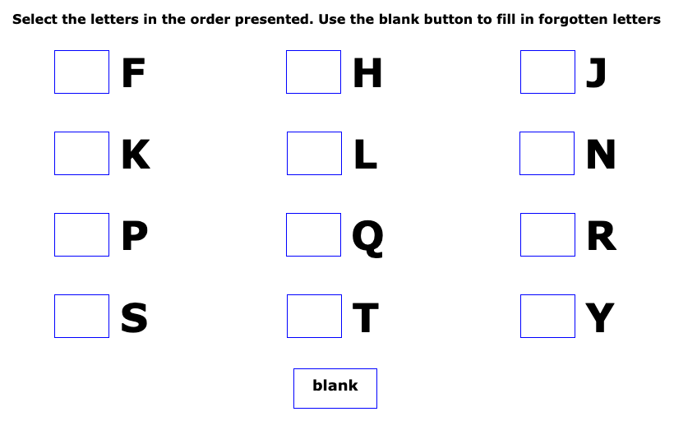

*Figure* *1*. This screen demonstrates where the participant would order the letters from the recall after the math problem has been answered.

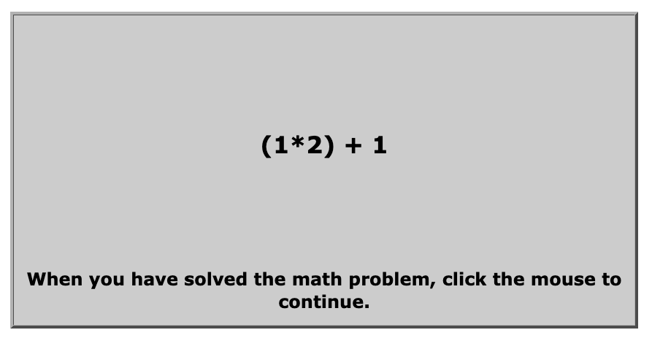

*Figure 2.* This screen shows an example of the math operations presented to the participant.

*Advanced Raven Progressive Matrices (APM).* The APM was setup through a Qualtrics survey for easier access. It consisted of three practice demonstrations. For example, in Figure 3, the participant sees eight patterns that build on one another and then a blank box. They are told to complete the pattern by choosing one the eight patterns below the image that best fits the original pattern. Below that image is eight possible options that could complete the pattern. Since this is a practice problem, the participant is told that numbers 4, 6, and 7 cannot be correct because they only show one circle. The participant is also told that numbers 1, 3, and 5 cannot be correct because they only show two circles. The last thing they are told is that number 2 cannot be correct because it has too many circles. This leaves number 8 to be the correct option. All 36 matrices reflect this type of abstract thinking. After the participant completed the practice demonstrations, they started the APM. For the APM, it was required of the participant that they answer the current question before moving onward to the next. The participants completed Set Two of the APM, containing 36 problems and they had 25 minutes to complete it. Scores can range from 0 to 36.



*Figure 3.* This is the practice problem included in the instructions for the APM

*Typing Task.* The typing task is a words per minute typing task administered to all participants. It is a demonstration of expertise for those who do not have any foreign language experience. For this task, we used an online typing task ([www.TypingTest.com](http://www.TypingTest.com)). The participant completed a 1-minute typing test from this website, specifically the option the “Rules of Baseball.” The participants had one minute to type as quickly and accurately as possible. Figure 4 demonstrates the prompt participants had to type. The timer started as soon as the participant began typing. The website keeps track of any typing errors the participant may have committed. Figure 5 shows an example of the participants raw typing speed, errors, and adjusted speed. Their typing speed is based on words per minute.

*Figure 4.* This figure is the prompt all participants had to type verbatim.

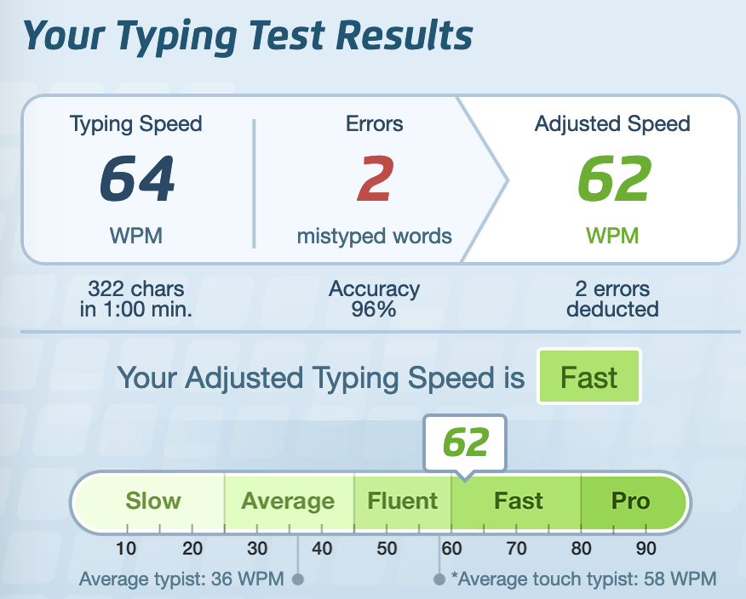

*Figure 5.* This figure shows the participants typing speed, errors, and adjusted speed

*Foreign Language Placement Exam.* This task was part of the experimental design for expertise. Participants would sign up for the foreign language portion. In addition to taking the typing task, the participants were also required to take Missouri State University’s Foreign Language Placement Exam given to those who wish to enroll in a foreign language course. The placement exam demonstrates proficiency in French, German, or Spanish. The entire exam is computerized and evaluates grammar, vocabulary, and reading comprehension in the above languages. For the reading comprehension questions, the participant is given a prompt in the second language and must answer a question about it (Figure X). After the exam is completed, they are given a score that represents which section of that language they should take (i.e., 101, 102, 201, 202 representing the four course sequence of foreign language requirement), and the point totals will be used as our measure of expertise. These scores will be translated into z-scores to be able to use a standardized metric for language expertise overall.

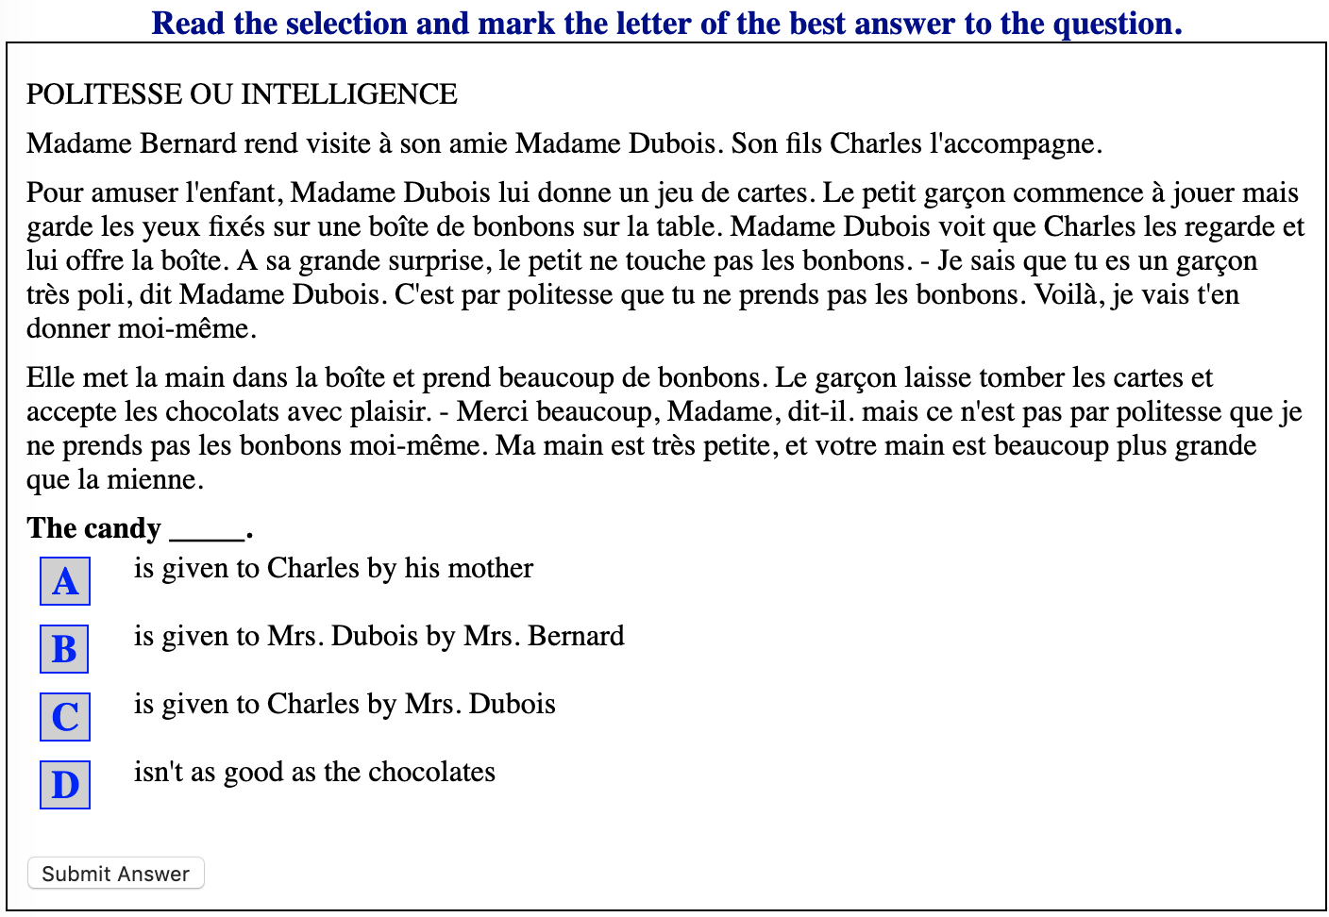

*Figure 6.* Example of a reading comprehension question in French.

*Figure 7.* These images demonstrate the amount of available points and the corresponding section the participant should take. In the following order are the points and sections assigned to that range of points for: French, German, and Spanish.

**Procedure**

Sessions were administered in groups of 1-24, dependent on how many participants had signed up for each time slot. All tasks were given to each participant during a session in the same order; however, the order was counterbalanced between sessions using a Latin square. Each session lasted for roughly 60 minutes, unless the participant had signed up for the foreign language section in which it took them approximately 90 minutes. The section with the foreign language placement exam started in this order: AOSPAN, APM, typing task, placement exam. The next section that came in for this task performed the tasks in this order: placement exam, APM, typing task, AOSPAN. The rest of the sections followed different variations of these until all combinations had been done and the experimenter started over. The section without the placement exam started in this order: AOSPAN, APM, typing task. The next section that came in for this task performed them in this order: typing task, placement exam, AOSPAN, APM. This Latin square design was used until all combinations had been performed by different groups of participants. By counterbalancing each group, we were able to balance potential carry over or fatigue effects for each section and time slot.

**RESULTS**

**Descriptive Statistics**

The typing test had a *M* = 46.73, *SD* = 15.24, with fastest words per minute (WPM) of 85, and the slowest WPM of 13. The APM had a *M* = 13.62, *SD* = 7.56, with the highest score of 26 and a lowest score of 0. The OSPAN had a *M* = 48.09, *SD* = 16.71, with the highest letter recall of 75 and the lowest letter recall of 10. There were 35 participants (*N* = 35) who scored at least 85% on the math portion of the OSPAN. The OSPAN for those participants was a *M* = 51.97, *SD* = 15.55.

**Hypothesis Tests**

Since there were only 6 participants who completed the foreign language placement exam, those hypotheses and foreign language scores were not analyzed due to the low sample size. Instead, the typing test for all participants was used as the measure of expertise. Therefore, three correlations were calculated. The first was to confirm the relationship between the APM and the OSPAN. The correlation was *r* = .57. 95% CI [.33, .74], *p* < .001. This finding confirms that fluid intelligence (*gF*) and working memory (WM) were positively correlated, as shown in previous research (Conway et al, 2012; Shelton et al, 2010). The second correlation analyzed was the typing test and the APM, and the correlation was not significant, *r* = .23, 95% CI [-.07, .50], *p* = .13. The final correlation observed was the OSPAN and the typing test, and this correlation was also not significant, *r* = .22, 95% CI [-.09, .50], *p* = .16. Since over a quarter of the sample did not perform the math portion to the recommended 85%, we performed regression models using the math score as a covariate to determine the relation (*pr*) between variables controlling for math performance.

The first regression model was the APM predicted by the AOSPAN’s letter recall score and math accuracy, *F*(2, 41) = 13.70, *p* = < .001, *R2*= .40. The partial correlation of AOSPAN and APM was *pr* = .43. The second regression model was the typing score predicted by the OSPAN’s letter recall and math accuracy, *F*(2, 38) = 1.31, *p* = .28, *R2* = .06. The partial correlation of the typing test and AOSPAN letter recall and math accuracy was *pr* = .14. Since the APM scales did not depend on math accuracy, no regression was necessary to determine a partial relationship between APM and the typing test.

Our original power analysis was based on an *a priori* correlation with two tails. We hoped for an effect size of *r* ~ *.*30 (*r2* = .09), at 80% power, and alpha = .05. Using G*Power, this analysis yielded a sample size of 82 participants. However, when a power analysis was examined *a posteriori*, controlling for our average correlations for the typing test and the APM (*r* = .23) and the OSPAN and typing test (*r* = .22), we would have needed about 159 participants to detect a significant relationship between these correlations at alpha < .05.

**DISCUSSION**

Expertise and working memory studies have been performed focusing on various psychological research topics. Very few studies, however, include fluid intelligence and its relationship to expertise. This experiment was designed to compare expertise and working memory again, and then see how expertise and fluid intelligence are related as well. The original hypothesis was that those who have a higher expertise in foreign language or in the typing task, will have a higher working memory AOSPAN scores and higher fluid intelligence APM scores. Instead for global expertise, we used the typing scores to correlate with AOSPAN, and APM to examine this hypothesis. Performance on the AOSPAN task in the math sections was further used as a covariate to account for participant differences in this portion of the AOSPAN task.

First, we replicated the correlation between working memory and fluid intelligence showing *r = .57* and then *pr* = .43 controlling for math scores. Next, we extended these correlations to expertise. The correlation for the APM and typing test was *r* = .23, and the correlation for the AOSPAN and the typing test was *r* = .22, with a of *pr =.*14*.* These results do not indicate support for our hypothesis that expertise and working memory or fluid intelligence are significantly related; however, the limitation of small sample size should be considered. Our sample size was not as large as it needed to be to have plenty of usable data for all parts of the experiment. For example, we were only able to collect six participants for the foreign language as an expertise part of our study, mostly scoring into the introductory course for their language. More variability and scores would be necessary to fully examine this variable.

Future directions of the study would be to replicate this experiment again with a larger sample size, primarily in using foreign language as a form of expertise and examine the same results. The original experiment showed a correlation between the AOSPAN and APM of *r* = .57. While the typing test correlated with these at *r* = .23 (APM) and *r* = .22 (AOSPAN). Since working memory and *gF* were not perfectly correlated it is interesting that their correlations with the typing task were almost the same, and not very strong. Perhaps using a different form of expertise that relates closer to working memory and *gF*, instead of typing, could make a difference and make this a stronger correlation.

**CONCLUSION**

All research is important and should be constantly adapted for the field of psychology. Working memory, *gF*, and expertise will continue to grow in the field and adapt to what researchers find. Although our only significant finding was that working memory and *gF* are still positively correlated, there may be others who find this research helpful in their work. Other researchers may find that expertise is related to different areas of working memory; for example, in short term or long-term working memory. Whereas they may also find expertise relates to different areas of intelligence besides fluid intelligence.

**REFERENCES**

Amthauer, R., Brocke, B., Liepmann, D., & Beauducel, A. (2001). Intelligenz-Struktur-Test 2000 R. *Göttingen: Hogrefe*, *2*.

Baddeley, A. D., (1986). *Working memory*. Oxford: Clarendon Press.

Baddeley, A. D., (2002). Is working memory still working? *European Psychologist*, *7*(2), 85–97. doi: 10.1027//1016-9040.7.2.85

Baddeley, A. D., & Hitch, G. J. (1994). Developments in the concept of working memory. *Neuropsychology*, *8*(4), 485–493. doi: 10.1037/0894-4105.8.4.485

Cattell, R. B. (1963). Theory of fluid and crystallized intelligence: A critical experiment. *Journal of Educational Psychology*, *54*(1), 1–22. doi: 10.1037/h0046743

Chase, W. G., & Simon, H. A., (1973). Perception in chess. *Cognitive Psychology, 4*(1), 55-81. doi: 10.1016/0010-0285(73)90004-2

Chi, M., Feltovich, P., & Glaser, R., (1981). Categorization and representation of physics problems by experts and novices. *Cognitive Science*, *5*(2), 121-152. doi: 10.1207/s15516709cog0502_2

Chi, M., Glaser, R., & Rees., E. (1982). Expertise in problem solving. In R. J. Sternberg (Ed.), *Advances in the Psychology of Human Intelligence,* (Vol. 1). Hillsdale, NJ: Erlbaum.

Conway, Andrew R. A., Cowan, B., Bunting, M. F., Therriault, D. J., & Minkoff, Scott R. B., (2002). A latent variable analysis of working memory capacity, short-term memory capacity, processing speed, and general fluid intelligence. *Intelligence*, 30, 163-183. doi: 10.1016/s0160-2896(01)00096-4

Daneman, M., Carpenter, P. A., (1980). Individual differences in working memory and reading. *Journal of Verbal Learning and Verbal Behavior*, 19(4), 450-466. doi: 10.1016/S0022-5371(80)90312-6

Faul, F., Erdfelder, E., Lang, A.-G., & Buchner, A. (2007). G*Power 3: A flexible statistical power analysis program for the social, behavioral, and biomedical sciences. *Behavior Research Methods*, *39*, 175-191. doi: 10.3758/bf03193146

Grabner, H. R., Neubauer, A. C., Stern, E. (2006). Superior performance and neural efficiency: The impact of intelligence and expertise. *Brain Research Bulletin,* 69, 422-439. doi: 10.1016/j.brainresbull.2006.02.009

Geary, David. (2009). *The evolution of general fluid intelligence*. In S. Platek & Shackelford, T.K. (Eds.), Foundations in Evolutionary Cognitive Neuroscience. (pgs. 22-56). doi: 10.1017/CBO9780511626586.002.

Gray, J. R., Chabris, C. F., & Braver, T.S (2003). Neural mechanisms of general fluid intelligence. *Nature*, 6(3), 316-322. doi: 10.1038/nn1014

Horn, J. L. (1968). Organization of abilities and the development of intelligence. *Psychological Review*, *75*(3), 242–259. doi: 10.1037/h0025662

Jaeggi, S. M., Buschkuehl, M., Perrig, W. J., & Meier, B., (2010). The concurrent validity of the *N*-back task as a working memory measure. *Memory*, *18*(4), 394-412. doi: 10.1080/09658211003702171

Kane, M. J., Hambrick, D. Z., Conway, A. R. A. (2005). Working memory capacity and fluid intelligence are strongly related constructs: Comment on Ackerman, Beier, and Boyle (2005). *Psychological Bulletin*, 131(1), 66-71. doi: 10.1037/0033-2909.131.1.66

Kirchner, W. K., (1958). Age differences in short-term retention of rapidly changing information. *Journal of Experimental Psychology*, 55(4), 352-358. doi: 10.1037/h0043688

Miller, G. A., (1956). The magical number seven, plus or minus two: Some limits on our capacity for processing information. *Psychological Review*, *63*(2), 81-97. doi: 10.1037/h0043158

Raven, J. C. (1936). Mental tests used in genetic studies: The performance of related individuals on tests mainly educative and mainly reproductive. MSc Thesis of University of London.

Redick, T.S., Broadway, J. M., Meier, M.E., Kuriakose, P.S., Unsworth, N., Kane, M. J., Engle, R.W., (2012). Measuring working memory capacity with automated complex span tasks. *European Journal of Psychological Assessment,* *28*(3), 164-171. doi: 10.1027/1015-5759/a000123

Robinson-Riegler, G., & Robinson-Riegler, B. (2004). *Cognitive psychology*. Boston: Allyn and Bacon.

Schmiedek, F., Hildebrandt, A., Lövdén, M., Lindenberger, U., & Wilhelm, O., (2009). Complex span versus updating tasks of working memory: The gap is not that deep. *Journal of Experimental Psychology: Learning, Memory, and Cognition,* *35*(4), 1089-1096. doi: 10.1037/a0015730.

Shah, P., & Miyake, A. (1996). The separability of working memory resources for spatial thinking and language processing: An individual differences approach. *Journal of Experimental Psychology: General, 125*(1), 4–27. doi: 10.1037/0096-3445.125.1.4

Shelton, J. T., Elliott, E. M., Matthews, R. A., Hill, B. D., Grouvier, W. D. (2010). The relationships of working memory, secondary memory, and general fluid intelligence: Working memory is special. *Journal of Experimental Psychology: Learning, Memory, and Cognition,* *36*(3), 813-820. doi: 10.1037/a0019046

Turner, M., Engle, R. W., (1989). Is working memory capacity task dependent? *Journal of Memory and Language*, 28(2), 127-154. doi: 10.1016/0749-596X(89)90040-5

Unsworth, N., Engle, R. W., (2006). Simple and complex memory spans and their relation abilities: Evidence from list-length effects. *Journal of Memory and Language,* 54, 68-80. doi: 10.1016/j.jml.2005.06.003

Unsworth, N., Heitz, R.P., Schrock, J.C., Engle, R. W., (2005). An automated version of the operation span task. *Behavior Research Methods,* *37*(3), 498-505. doi: 10.3758/BF03192720

Waugh, N. C., & Norman, D. A. (1965). Primary memory. *Psychological Review*, *72*(2), 89–104. doi: 10.1037/h0021797

Yuan, K., Steedle, J., Shavelson, R., Alonzo, A., Oppezzo, M., (2006). Working memory, fluid intelligence, and science learning. *Educational Research Review*, *1*(2), 83-98. doi: 10.1016/j.edurev.2006.08.005